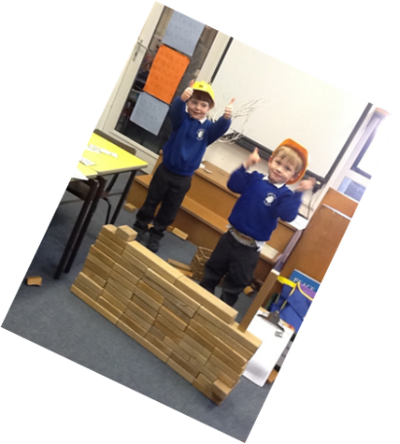
Nursery Newsletter Spring 2019

We hope you have had a lovely Christmas break and that your children are now well rested and all ready for an exciting new term.
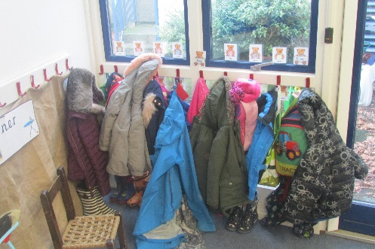
We have made some small changes to the classroom this January which will mean some small adaptations to the children’s routine. Our nursery base will now be in Helvellyn which can be entered via the school hall. All nursery children will be welcomed here at the start of every morning session. Each child has been given a peg with their name on and under their peg would be a good place to keep their wellies. All children will need their own wellies for this term, if possible, as we will be accessing the outdoor area each session whatever the weather! If you would like to include a puddle suit on your child’s peg that would also be useful. If your child is staying at nursery for their lunch, we will have the daily choices listed in our new snack area in Helvellyn. There is always a hot option, a vegetarian and a baked potato option.

On a Monday morning we will be opening up a “Book Exchange”. We now have a small Reading Area within our classroom and on a Monday, we would like to invite parents, before they leave, to help their child select a new book to keep for the week. These books will need to stay in your child’s book bag during the sessions they are in nursery, as throughout the week we will be finding time to share our stories. We will be chatting about characters in the children’s story books and whether anything interesting happens to these characters. We will also be setting up a book chart where we will be recording whether our books are happy, sad, boring or exciting. I will include a short note in your child’s Reading Record regarding their response to each book and please feel free to add your own notes as you share books with your children at home.

We will be continuing with Show and Tell from Monday 21st January, but we have split the children into smaller groups. These will run on a rolling programme with each group taking turns as follows:
Monday 21st January: (Group 1) Isla H, Hector and Lauren
Monday 28th January: (Group 2) Lucas, Isla S and Jacob
Monday 4th February: (Group 3) Elmer, May and Cory
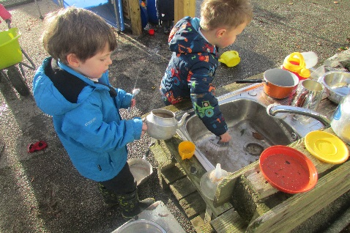
Monday 11th February: Group 1
Monday 25th February: Group 2
Monday 4th March; Group 3
Monday 11th March: Group 1
Monday 18th March: Group 2
Monday 25th March: Group 3.
Our current topic this half term is “Toys” and it would be useful if your child could select a toy from home to bring in to share.” This may include an old toy, as we will be exploring toys from the past, as well as looking at modern toys, how they are made and how they work.

We also have some homework to link with our topic this half term. We would like each child to create a personal scrap book at home with photos and drawings of all the members of their family with their favourite toys or games. You can present the books however you wish to make it personal to your child. We will be laminating these scrapbooks and putting them in our book corner for the children to share together.
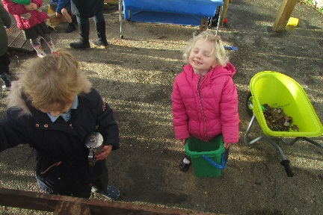
Many thanks for all your continuing support.

Mrs Hayes

