CHRISTIAN AID WEEK
May 10TH - 16TH
Fighting Covid-19 in an over-crowded shanty town
or refugee camp, without clean water or being able
to socially distance yourself? … Simply impossible!
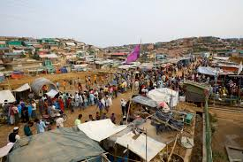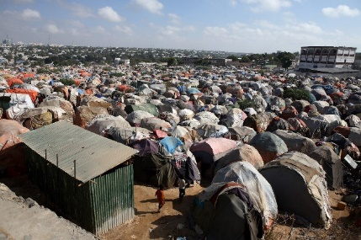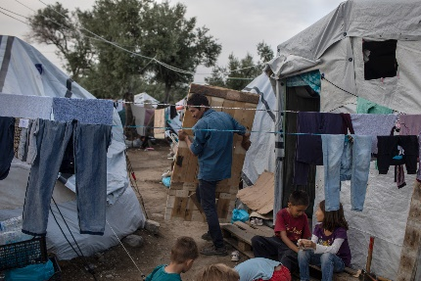
But millions of the world’s poorest people will
be put in that situation as the virus spreads.
The impact on them will be catastrophic, but also
on the rest of the world unless we can get global control over this dangerous virus.
Christian Aid needs your help more than ever this year, to help the world’s poor. Please give
whatever you can afford – however little that may be. Every little helps!
Online at: www.christianaid.org.uk/caw
‘Phone: 020 7523 2269 or 08080 006 006
Thank you in advance for your support!

