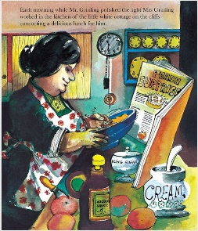
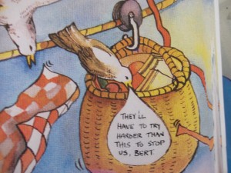

Reception Expressive Arts and Design – design a new container to stop the seagulls from stealing Mr Grinling’s lunch

In the story Mrs Gringling sends Mr Grinling his lunch each day in a picnic basket, but the seagulls keep stealing it. Two weeks ago, you thought about the good things and the problems with the basket. With these two things in mind, I would like you to design a new container to carry Mr Grinling’s lunch down the wire which won’t let the seagulls in! Draw your design below and ask a grown-up to label it for you. Then make a list of the materials you will need to use to make it.

