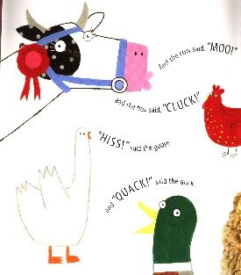
What the Ladybird Heard ‘pick and mix’ activities
Reception
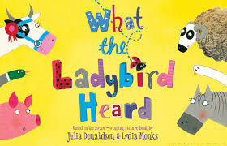
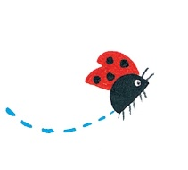
Can you identify some of the rhyming words in the story? Ask an adult to make a list of the ones you notice as you listen to one of the stories. | Design your own farm map to trick Lanky Len and Hefty Hugh. Where will they be caught?
Be a ladybird detective! I have attached a ladybird spotting checklist courtesy of Wildlife Watch. See how many different types of ladybirds you can find in your gardens or out on your walks. Make a poster to tell me about what you found. A clue – ladybirds can usually be found in hedges, woodland, trees and amongst grass. | See if you can find any pebbles which you could paint into the Ladybird and some of the other characters from the story. Can you use them to retell one of the stories?
Be a good listener like the Ladybird in the stories and next time you go out for a walk write down all the sounds you can hear. I bet there are more than you think there will be! | Design a new ladybird. What will it look like? How many spots and legs will it have? What colour will it be and where will it live?

