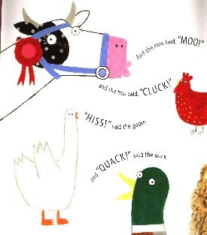
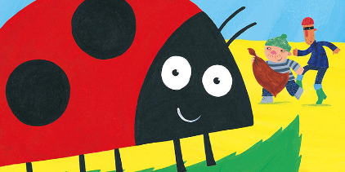
What the Ladybird Heard ‘pick and mix’ activities
Reception
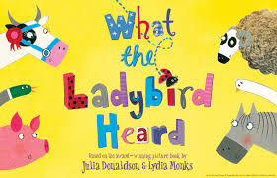
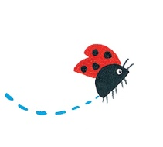
Can you identify some of the rhyming words in the story? Ask an adult to make a list of the ones you notice as you listen to one of the stories. | Design your own farm map to trick Lanky Len and Hefty Hugh.
Be a good listener like the Ladybird and next time you go out for a walk write down all the sounds you can hear. I bet there are more than you think there will be!

