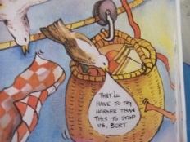
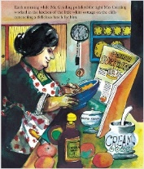
Year One Design Technology – design a new container to keep Mr Grinling’s lunch safe
Two weeks ago you thought about the good and bad things about the picnic basket in the story. You also thought about how it might be improved. Keeping your ideas for improvement in mind, I would like you to design a new container to keep Mr Grinling’s lunch safe from the seagulls. Use the design template below to record your ideas. Remember, whatever you design it still needs to be able to travel along the line from the cottage to the lighthouse.
I am designing a: | I will need these materials and have chosen them because:
I will need this equipment: | My design looks like this:

