Bowfell Class EYFS curriculum overview Autumn Term 2020
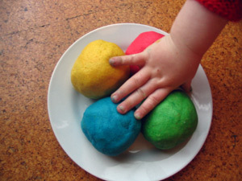  Area of learning | Autumn Term 2020
Focus texts: The Colour Monster, Supertato,
The Gruffalo & One Snowy Night
Physical Development | - Squiggle while you wiggle!  - Funky Fingers area with a weekly focus  - Playdough kitchen  - Dough disco  - Outdoor play  - Painting/creative/ writing areas with activities  - Bikes and trikes time  - PE – parachute games, gymnastics, team games and dance
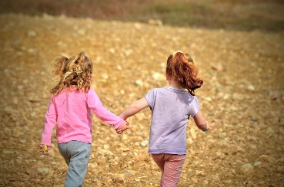  Communication and Language &  Personal, Social and Emotional Development  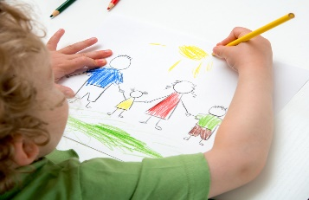 | - Phases 1/2/phonics  - Circle & morning chat time  - Snack time  - Settling in, rules and routines/expectations  - Feelings & emotions  - Building relationships with peers and adults  - Curiosity box – new for this year, look out on the blog for more details!  - Voting station
Literacy  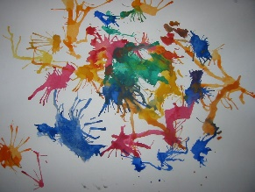 | - Phases 1 and 2 phonics  - Phonics challenges during continuous provision time  - 1:1 reading (Reception only)  - Story telling using ‘Talk for Writing’ approach  - Literacy Lodge  - Name recognition (N) and writing (R&N)
Expressive Arts and Design | - Creative area  - Playdough kitchen  - Painting area  - Construction and loose parts area
Understanding the World & RE  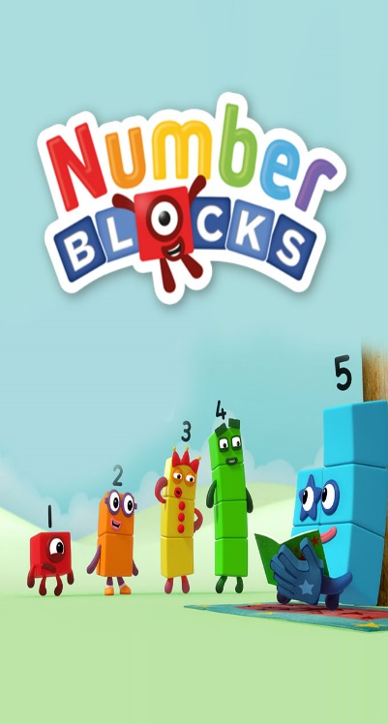 | - Celebrations including Harvest & Christmas  - Curiosity box – new for this year, look out on the blog for more details!
Mathematics | Nursery:  Number and place value:  - counting principles  - comparing amounts  Geometry:  - recognising, naming and matching colours  - sorting by various attributes  - introduction to simple patterns  Measurement:  - my day  Reception:  Number  - match and sort, compare amounts  - representing - 1, 2 &3  - comparing – 1,2, &3  - composition of – 1,2 & 3  - representing numbers to 5  - more and less  Measure, shape & spatial thinking:  - compare size, mass & capacity  - exploring patterns  - circles & triangles  - positional language  - shapes with 4 sides  - time  - Maths area  - Numberblocks

Dear Parents,

I do hope that you and your families are all well and that you have managed to enjoy some time together over the summer enjoying some of the beautiful weather we have had.
Welcome to the Autumn term in Bowfell Class for our Nursery and Reception children. This is a very special term for the children and we are looking forward to sharing this learning journey with them as well as yourselves.
Please see the information above for details about the learning opportunities children in Nursery and Reception will have in the Autumn Term. The children will learn through a combination of self-initiated independent learning and adult-led activities. We value highly the children’s interests and what sparks their imaginations which is why we have chosen to use different stories to base their learning around rather than structured topics. This provides the children with greater autonomy over their learning and may mean we spend a few days on something or even a few weeks. Stay tuned to the school blog and Tapestry to see where the children take us on their learning journey…
Teaching and learning in Nursery and Reception
Over the past couple of years Bowfell Class has grown in many ways, therefore from next week we will be welcoming Miss Zoe Eastham to our team as an additional class teacher. Miss Eastham enjoyed two successful placements at Levens throughout her teacher training year in 2018/2019. She is an energetic, passionate and creative class teacher who will be an asset to our team. Miss Eastham will be working alongside Mrs Haslam and teaching in both Year One and in Reception and Nursery. Miss Butler and Mrs Troughton will continue to work in Bowfell Class supporting children across Nursery and Reception.
Lunches
Please discuss with your child the lunch menu for each day before they come into school to ensure they understand the options available and are happy with their choice.
Clothing
Please ensure your child is suitably dressed for the weather each day which may include bringing a coat, sun hat and cream to school at the beginning of the term. Please ensure your child has sun cream applied in the morning and if they need more during the day then a bottle which is named can be brought into school and left (please note they cannot be sent home each day). Please ensure your child has a pair of wellies and a puddlesuit/waterproofs which can be left in school.
PE
PE for children in Nursery and Reception this year will be on Tuesdays and Fridays. Please can your child come to school on these days dressed in their PE kits which they will remain in for the day. Please note that school PE kit is optional for children in Nursery, however children should come in trainers and tracksuit bottoms/leggings and a suitable top if they are not wearing a school PE kit.
Reading books
Children in Reception will begin to bring home reading books over the next few weeks. Moe information about how we teach reading and how to support your child at home will follow.
Letters
Any slips that need returning can be placed in the basket which a member of staff will have by the Bowfell gate each morning. Please can your child place them in the basket as they enter the gate; we will not routinely be checking book bags for returned slips/letters.
Please do get in contact with me via the class email address if you have any queries or concerns: Bowfell@levens.cumbria.sch.uk

Many thanks for your continued support.
Kind regards,

Mrs Haslam and the Bowfell Team

