Bowfell Class EYFS curriculum overview Spring Term 2021
Area of learning | Spring Term 2020
 | Focus texts: Whatever Next! The Three Little Pigs,The Little Red Hen, A Squash and a Squeeze, Peppa Pig’s Chinese New Year, Dinosaur Bones and Jasper’s Beanstalk
Physical Development  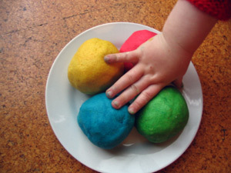 | - Squiggle while you wiggle!  - Funky Fingers area with a weekly focus  - Playdough area with changing enhancements  - Dough disco  - Outdoor play  - Painting/creative/ writing areas with activities  - Bikes and trikes time  - PE – Playground games and yoga
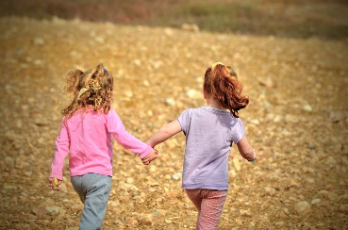  Communication and Language &  Personal, Social and Emotional Development  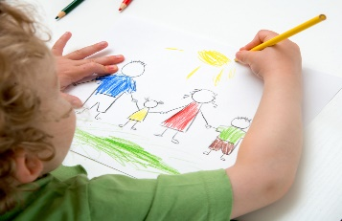 | - Phases 1/3 phonics  - Circle & morning chat time  - Snack time  - Settling in, rules and routines/expectations  - How are we similar? How are we different?  - Building relationships with peers and adults  - Curiosity box - prompts about our next topic to spark interest, wonder and conversation  - Voting station – which book should we read today?
Literacy | - Phases 1 and 3 phonics  - Phonics challenges during continuous provision time  - 1:1 reading (Reception only)  - Guided writing sessions (Reception only)  - Story telling using ‘Talk for Writing’ approach  - World Book Day  - Responding to our focus texts through various activities  - Story telling and literacy shelves
Expressive Arts and Design  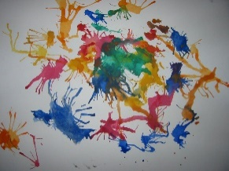 | - Creative area  - Playdough kitchen  - Painting area  - Construction and loose parts area  - Role-play area  - Focused adult-led tasks linked to our current book  - Music – exploring and using different instruments
Understanding the World & RE  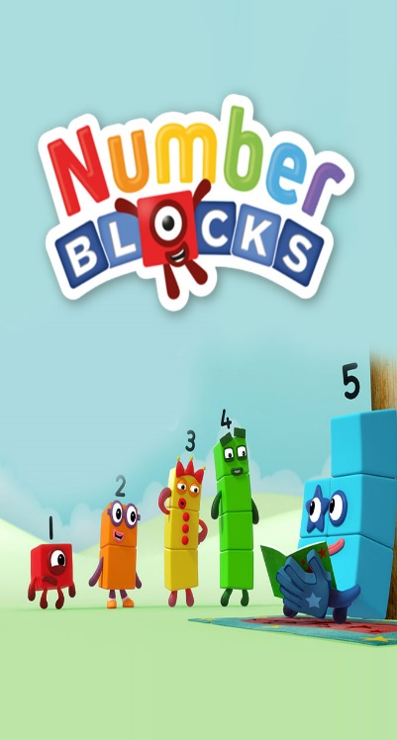 | - Baptism  - Easter  - Shrove Tuesday  - Space  - Plants and growing  - The past - dinosaurs  - Curiosity box provocations  - Chinese New Year themed celebration week  - Internet Safety Day  - STEM shelves
Mathematics | Nursery:  Measurement:  - my day  Number and place value:  - understanding numbers 0-5  - consistent 1:1 correspondence when counting  - begin to select quantities of objects up to 5 from a larger group and counting to check  Shape:  - awareness of simple shapes and their names  - recognition of shapes in the environment  Reception:  - introducing zero  - comparing numbers to 5  - composition of 4 & 5 6, 7 & 8  - making pairs  - combining 2 groups  - 9 & 10  - comparing numbers to 10  - bonds to 10  - compare mass  - compare capacity  - length & height  - time  - 3D-shape  - pattern

Dear Parents,
I hope that you and your families are all well and have enjoyed a lovely Christmas and New Year break.
Welcome to the Spring term in Bowfell Class for our Nursery and Reception children. Please see the information above for details about the learning opportunities the children will have in the Spring Term. The children will continue to learn through a combination of self-initiated, independent learning and adult-led activities. We value highly the children’s interests and what sparks their imaginations which is why we have chosen to use different stories to base their learning around rather than structured topics. This provides the children with greater autonomy over their learning and may mean we spend a few days on something or even a few weeks. Stay tuned to the school blog and Tapestry to see where the children take us on their learning journey…
Teaching and learning in Nursery and Reception
Teaching and learning in Bowfell Class will continue to be led by Mrs Haslam and supported by Miss Butler and Mrs Harwood. Children in Nursery have been allocated a key worker, please check your child’s Tapestry account for further details.
Lunches
Please discuss with your child the lunch menu for each day before they come into school to ensure they understand the options available and are happy with their choice. If your child is in Nursery and attends afternoon sessions, please ensure they arrive promptly at 11.30am for their lunch.
Clothing
Please ensure your child is suitably dressed for the weather each day. If your child is in Nursery and chooses not to wear a school uniform, please send them with enough warm layers of clothing. Each child needs to have a pair of wellies and a puddlesuit/waterproofs which must be left in school. In addition to this, all children are required to have a few spare sets of clothing which can be kept on their peg in case of accidents.
PE
PE for children in Nursery and Reception will continue to be on Tuesdays and Fridays this term. Please can your child come to school on these days dressed in their PE kits which they will remain in for the day. Please note that school PE kit is optional for children in Nursery, however children should come in trainers and tracksuit bottoms/leggings and a suitable top if they are not wearing a school PE kit.
Reading books (Reception only)
Thank you so much for your continued support in helping your child learn to read. We will continue to listen to children read three times each week when their reading books will also be changed if necessary. We encourage children to re-read their books as this helps to develop greater word recognition and fluency. Sometimes children may read a book three times before it is changed in order for them to be completely confident with a text. Please continue to listen to your child read each day; 5 minutes is adequate, but if they are eager to do more, great! Please indicate that you have listened to your child read by leaving a short comment or signature along with the date in your child’s record.
Letters
Any slips/payments that need returning to school directly can be placed in the class box next to where the water bottles are kept. It would be helpful if your child could carry these into school with them as we do not routinely check book bags for returned slips/letters.
Please do get in contact with me via the class email address if you have any queries or concerns: Bowfell@levens.cumbria.sch.uk

Many thanks for your continued support.
Kind regards,

Mrs Haslam and the Bowfell Team

