Monday 25th March 2024

Dear Parents and Carers,

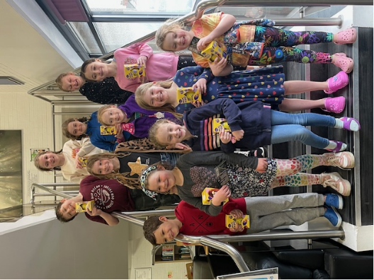As we approach the end of the spring term, it’s good to celebrate and reflect on some of the highlights of the term and there is no better way to start than to congratulate our twelve amazing swimmers from all across school who raised more than £1500 to buy a mobile cooking station to support curriculum cooking for every class in school. Three teams competed in The Rotary Swimathon held at Kendal Leisure Centre earlier this month, swimming a total of 460 lengths combined. This is usually an event for the older pupils only so it was very special to be able to enter a team from our infant class. They are already inspiring others to join them when we are likely to repeat the event next year and the team are also looking forward to being treated to a special cooking event of their own in the summer term as a reward for the exceptional achievement.

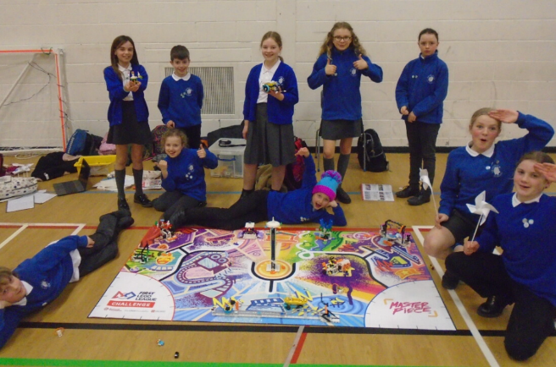Children from Class 4 took part in the Lego League challenge for the second year running under the expert direction of Mr Dean, our brilliant STEM ambassador. The event is split into four different but related challenges – an innovation project, in which students need to come up with a design for a new piece of technology which could be a real benefit to our world; a robot design competition; a robot game and an award for collaboration. The team have developed so many employable skills over the weeks that they have been preparing and as always, were fabulous representatives of our school.

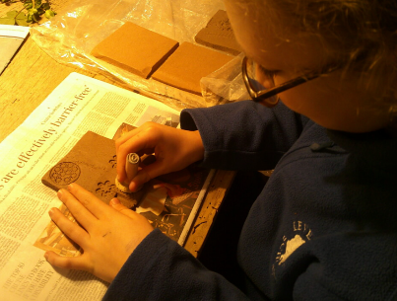Our year six pupils were recently treated to an afternoon with local potter Nigel Edmondson at his Levens studio as we embarked on our new whole-school art project to create a permanent ceramic art installation in our newly painted school hall. Year six pupils are now working with each class to support our collaborative piece inspired by the natural world.

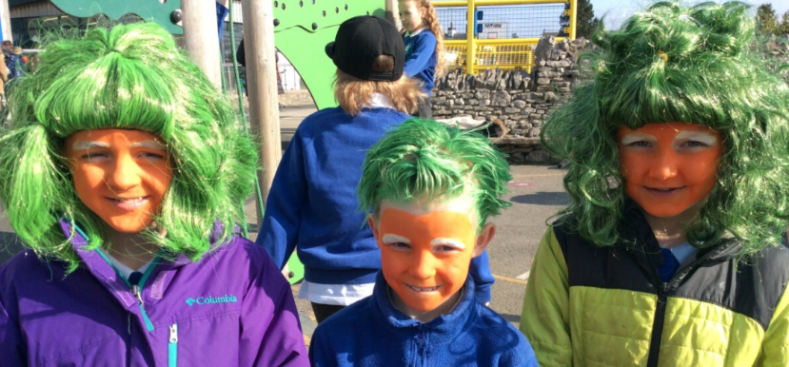Thank you to everyone for supporting our wild-hair World Book Day earlier in the month. Pupils celebrated books and reading for pleasure in various ways throughout the day with their peers. After the Easter holidays, our School Councillors will be invited to visit a local bookstore to select new books for our gorgeous new library environment.

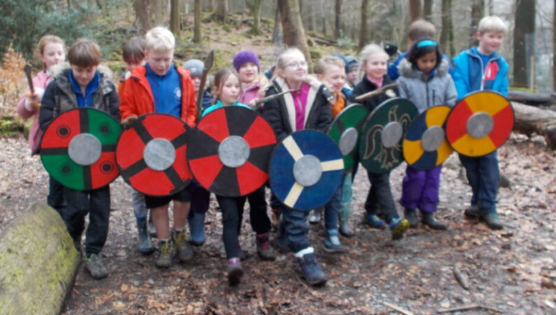Last Friday, class 3 treated us all to a very special celebration assembly when they shared their incredible learning on the Anglo-Saxons and Vikings over this term. They also told us all about their history day at Woodmatters in Windermere and shared some of the things that they have made like coins and quills and Sutton hoo helmets, as well as their wonderful writing and research. Look out for the blog dropping onto the website very soon!



Despite the wet weather, we enjoyed running our five miles for Comic Relief – a much healthier option than making cakes! Thank you for all your efforts to have your children ready to run each day and for the incredible sponsorship from all our families. Together we have raised an outstanding £1,115 for this incredible charity.



Look out for news of our next fundraising event inspired and led by Harry’s passion for the environment and endangered species in the summer term!

**Staff News:**

After the Easter holidays we will be welcoming Mrs Georgie Dawson to the Levens team who will be supporting the administration and daily running of our very busy office environment. I am sure you will want to join with the staff in welcoming her to our school. Mrs Dawson has extensive experience working in schools in the South Lakes area in a variety of roles and we are very excited to have her joining us very soon.

In terms of contacting school after the Easter holidays, there will be no change, but please note that your email or telephone call might now be dealt with by Mrs Dawson, as well as Mrs Coker, depending on the day or time of your correspondence.

In other staff news, we are really pleased that Miss Heaton, Mrs Lawless and Miss Rockcliffe have now officially joined the Levens staff team. We hope that they will continue to be a strong complement for team long into the future as they provide such a significant contribution to our pupils.

**Health and Safety – Important Reminders:**

Staff in the dining hall have noticed that nuts seem to be creeping back into lunchboxes in recent weeks. Our policy on nuts is an extremely important one as we have children in school with significant nut allergies. Children should not bring foods containing any nuts. Please carefully check ingredients of foods before sending them in with your child.

All medication needs to be brought to the school office in the morning so that the correct paper work can be completed by parents or carers. Children should not bring in their own medication and store it in their bags. We have detailed and clear procedures to support children requiring medication in school but also to protect other children. For further information, please refer to our policy on our website.

**Term Dates:**

Please follow this link for dates for your calendar for the remainder of this year and into next academic year - [**Levens School - Term dates**](https://www.levens.cumbria.sch.uk/information/term-date/)**.**

**Patterdale:**

This week, a medical form will be emailed to all of our Class 4 parents and carers. If you child requires medicine whilst we are away, please ensure you download this form, complete it and return to the school office on our first day back, Tuesday 16th April. Medication should be handed to the office on the morning of departure by 8.45am.

**Forthcoming Events:**

Please keep in touch with our calendar as events for the summer term are added regularly and it’s always a busy one. So far, it includes Class 4 on their three-day residential in Ullswater at Patterdale Hall; workshops with the whole school from United Utilities to develop knowledge and understanding of the impact of our water use in the environment; A rounders tournament for Class 3; Celebration Assemblies for parents and families; and of course, our Outdoor Education days at Kepplewrey.

**Before we finish for Easter, why not join us at our Easter Service at St. John’s this Tuesday morning at 9.30am.**

**Please note that we finish for the Easter holidays this Thursday at 2pm and there is no YoYo provision available.**

**We return to school on Tuesday 16th April from 8.35am.**

On behalf of everyone at Levens, I hope you enjoy a relaxing, healthy and happy Easter break and we will see you for the start of the summer term. Let’s pray for some more warm sunshine as each day gets a little longer!

With my very best wishes



Jane Farraday