Early Years Foundation Stage Policy __ Levens CE School

Vision

“When we give every child the best start in their early years, we give them what they need today. We also set them up with every chance of success tomorrow.”
Development Matters [DfE, 2021]
At Levens, we pride ourselves on offering a high-quality early years education which provides our children with a secure and confident start to their school life. We are committed to nurturing a lifelong love of learning alongside the aims of the EYFS statutory framework. We strive for high standards, consider the development of the whole child and seek to foster resilience and independence. We aim to provide the essential knowledge that children need to prepare them for their future success and to give them the best possible start to their early education. We provide inviting classroom environments indoors and outdoors to stimulate learners and engage them in developing the three ‘Characteristics of Effective Learning’ as set out within the EYFS statutory framework.

The Early Years Foundation Stage (EYFS) sets the standards that all early years providers must meet to ensure that children learn and develop well and are kept healthy and safe. It promotes teaching and learning to ensure children’s ‘school readiness’ and gives children the broad range of knowledge and skills that provide the right foundation for good future progress through school and life.

Seven Key features of effective practice in the Early Years

The best for every child:
At Levens, all children will be given an equal chance of success. We ensure that all children have access to high-quality early education. We pay particular attention to those children from disadvantaged backgrounds to ensure they have the same opportunities as their peers.
We provide high-quality early education and care which is inclusive for all children. Children’s special educational needs and disabilities (SEND) are identified quickly. All children promptly receive any extra help they need, so they can progress well in their learning.

High-quality care:
Our highly skilled staff team work hard to ensure the children’s experience is the central focus of thinking. We ensure our young children are well cared for to enable them to thrive. High-quality care is consistent. All practitioners enjoy spending time with young children and this is reflected in their interactions. Practitioners are responsive to children and ensure they form effective and positive relationships with them. We support children to develop high levels of independence.

The curriculum:
Our unique curriculum is carefully planned across three years in order to cater for children who join us in Nursery for two years prior to their Reception year. Themes, texts and learning opportunities are well-planned and focus on helping all children to develop their language skills. Flexibility is built into our curriculum in order to allow us to follow children’s interests in their learning. British Values are interwoven through all aspects of our teaching, interactions, curriculum, provision and the school’s Christian Values.

Pedagogy:
Every child is enabled to make progress in their learning, with the right help. We utilise different approaches to learning to ensure all children make progress. Children learn through play, by adults modelling, by observing each other, and through guided learning and direct teaching. We carefully organise enabling environments for high-quality play. Children in our early years also learn through group work when practitioners guide their learning. As the children develop throughout their Reception year they are given more guided learning. We have a well-planned learning environment, indoors and outdoors.

Assessment:
Assessment in our Early Years unit is ongoing and used to inform planning and support practitioners in identifying children who need additional support. It is based upon our staff’s secure knowledge of child development. We have clear expectations about what children need to know and how best to support them in developing their learning. All children at Levens are assessed in their communication and language skills upon entry and provided with appropriate support to develop these skills if necessary.

Within the first 6 weeks that a child starts reception, the class teacher will administer the reception baseline assessment (RBA). [The requirements for the RBA are set out in Annex B of EYFS statutory framework]

Children at the end of their Reception year are assessed against a set of 17 early learning goals. These are to inform parents and carers of their child’s progress at the end of the year and provides the Year One teacher with a holistic view of each child’s learning and development.

Self-regulation:
As part of our ‘Personal, Social, Emotional Development’ teaching and provision, we support each child’s ability to:
- Hold information in mind and focus their attention.
- Think flexibly and inhibit impulsive behaviour.

These abilities contribute to children’s growing ability to self-regulate:
- Concentrate their thinking.
- Plan what to do next.
- Monitor what they are doing and adapt.
- Regulate strong feelings.
- Be patient for what they want.
- Bounce back when things get difficult.

Partnership with parents:
We strive to build strong and respectful relationships with parents and carers and work in partnership alongside them which enables children to thrive in the early years. We listen regularly to parents and provide clear information about their children’s progress through parent meetings and electronically via Tapestry. Parents are encouraged to support their child’s learning and development at home as this has a significant impact on learning. We pride ourselves on the relationships we build with parents and carers and spend time getting to know and understand our children and their families, enabling us to offer support as needed. We carry out home visits before the children start in our early years. This provides the foundation for strong and effective partnerships with parents. At Levens, we implement the key person approach to help your child feel safe, confident and cared for whilst they are in school. This approach means that there is one named member of staff to act as the main point of contact for each child and their parents/carers.

The Early Years Foundation Stage Statutory Framework

Characteristics of Effective Learning describe behaviours children use in order to learn. To learn well, children must approach opportunities with curiosity, energy and enthusiasm. Effective learning must be meaningful to a child, so that they are able to use what they have learned and apply it in new situations. These abilities and attitudes of strong learners will support them to learn well and make good progress in all the Areas of Learning and development.
The three characteristics of effective teaching and learning are:
• Playing and exploring – children investigate and experience things, and ‘have a go’.
• Active learning – children concentrate and keep on trying if they encounter difficulties and enjoy their achievements.
• Creating and thinking critically – children have and develop their own ideas, make links between ideas, and develop strategies for doing things.

Learning and development
There are seven areas of learning and development that must shape educational programmes in early years settings. All areas of learning and development are important and inter-connected.
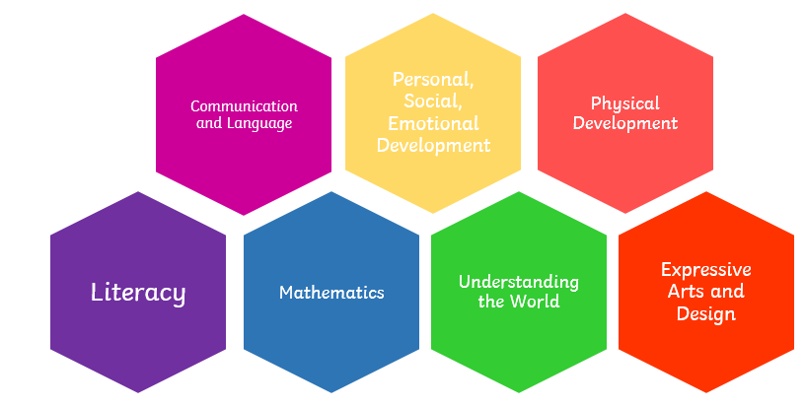

Three areas are particularly important for building a foundation for igniting children’s curiosity and enthusiasm for learning, forming relationships and thriving. These are the prime areas:
• communication and language
• physical development
• personal, social and emotional development
We also support children in four specific areas, through which the three prime areas are strengthened and applied.
The specific areas are:
• literacy
• mathematics
• understanding the world
• expressive arts and design

Roles and Responsibilities
The Early Years Lead actively seeks to develop their own personal and professional expertise through attending relevant courses, networking with Early Years Practitioners, attending cluster moderation; building partnerships with similar settings; and undertaking appropriate research.

Developing an annual action plan and keeping relevant policies up to date. The role involves:
- Developing a vision for our young children;
- Sharing and imparting expertise;
- Supporting staff professional development needs;
- Implementing change;
- Monitoring and assessing the effectiveness of our Early Years classes to provide the very best start for our children;
- Overseeing smooth transitions into Key Stage One.

Staff training
We will:
- Train all staff in safeguarding procedures in line with Annex C of the most recent EYFS framework and Keeping Children Safe in Education (KCSIE) guidance;
- Support all staff to feel confident in implementing our safeguarding policy and procedures;
- Renew training every 2 years, or more often when it’s needed to help maintain skills; keep up to date with any changes to our safeguarding procedures; or because of any safeguarding concerns;
- Outline how training is delivered, and how staff are supported to put it in place, in our child protection and safeguarding policies.
Our designated safeguarding lead (DSL) will:
- Provide ongoing support, advice and guidance to all staff;
- Attend a training course consistent with the criteria set out in Annex C of the most recent EYFS framework;
- Liaise as needed with local statutory children’s services agencies and our local safeguarding partners.

Absences
We are required to promptly follow up on absences. If your child is absent and we haven’t heard from you regarding the reason for their absence, we will attempt to contact yourselves and alternative emergency contacts. Please see our attendance policy for more information on this, including our expectations of parents/carers to report child absences.

Safer recruitment
When recruiting staff, we follow the procedures set out in the latest EYFS framework guidance on checking the suitability of new employees, including:
- Obtaining a reference for any member of staff (including students and volunteers) before they are recruited;
- Recording information about staff qualifications and identity checks, vetting processes and references
Please see our safeguarding policy for details of our safer recruitment procedures.

Policy Review

This policy is based on requirements set out in the statutory framework for the Early Years Foundation Stage (EYFS), effective from 1 September 2025.

This policy was agreed by the governing body of Levens CE School on
Signed -
Signed – Helen Haslam (EYFS Lead) April 2026
This policy is due for review in April 2028

